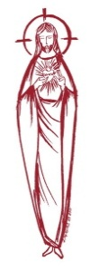
SACRED HEART PARISH

Sacred Heart Parish Founded 1814, The First Catholic Parish in the STate of New Jersey

Sacred Heart Church, 343 South broad Street, Trenton, New Jersey 08608

Holy Cross Church, 233 Adeline Street, Trenton, New Jersey 08611

ALL ARE WELCOME

Whatever your present status in the Catholic Church, whatever your current family or marital situation,

Whatever your past or present religious affiliation, whatever your personal history, age, background, or

race, whatever your own self-image or esteem, you are invited, welcomed, accepted, loved and

respected at the Parish of the Sacred Heart.

PASTOR

Rev. Msgr. Dennis A. Apoldite
frdennis@trentonsacredheart.org
PAROCHIAL VICAR
Rev. Charles Muorah
Rev. Marcin Kania, weekend Polish Mass
Felician Residence for Clergy
233 Adeline Street, Trenton, New Jersey 08611
609-393-4826 ext. 108 for Fr Charles
DEACONS
John Grussler and Dr. Christian Nnajiofor

Business Manager / ADMINISTRATIVE ASSISTANT
John DeSantis: secretary@trentonsacredheart.org
coordinator of religious education
Mary Tovar: reled@trentonsacredheart.org
COORDINATORS OF SACRED MUSIC
Natalie Megules ~ 609-575-6484
Rupert Peters ~ Gospel Mass 609-442-7871
MAINTENANCE DEPARTMENT
Frank Rios
Trustees
Jack Breuer and Ellieen Ancrum Ingbritsen,

OFFICE HOURS

9:00am – 4:00pm Monday – Friday

SACRED HEART PARISH OFFICE

343 South Broad Street, Trenton, NJ 08608

Phone: (609) 393-2801 ~ Fax: (609) 989-8997

WEB PAGE:

www.trentonsacredheart.org

CEMETERY RECORDS
Contact The Office of Catholic Cemeteries at 609-394-2017 or DirectorofCemeteries@DioceseofTrenton.org

SACRAMENTAL RECORDS
Sacred Heart Church, Saint John’s Church, Saint Francis Church, Saints Peter and Paul Church, Saint Stanislaus Church, Holy Cross Church, Blessed Sacrament Church, Our Lady of Divine Shepherd Church, Blessed Sacrament/Our Lady of Divine Shepherd Parish and Divine Mercy Parish.

Liturgy Schedule

Sacred Heart
Monday, Tuesday, Wednesday and Friday
12:10 Noon
Saturday Evening 5:15 PM
Sunday Morning 9:00 and 11:15 AM
HOLY CROSS
Monday, Thursday and Friday 8:00 AM
First Friday 6:30 PM Polish Mass
Saturday Evening 4:00 PM
Sunday Morning 10:00 AM Gospel
12:00 Noon Polish
For each Holy Day please reference the bulletin

SACRAMENTS
BAPTISM
Please call the Parish Office at least one month in advance.

RECONCILIATION

Every First Friday following the 12:10PM Mass SHC

Saturday afternoon ~ 4:30 to 5:00 PM SHC

Every Saturday from 3:30 to 3:50 PM HCC

Every Sunday 9:30 to 9:50AM HCC

and by appointment.
EUCHARISTIC ADORATION
First Saturday of the Month 2:30 to 3:30 pm
in Holy Cross Church
MARRIAGE
Please call the Parish Priest at least one year in advance to set up initial meeting and to confirm a wedding
date and time.
ANOINTING OF THE SICK
Please call the Priests any time 609-393-2801.
COMMUNION TO THE HOMEBOUND
Call the Parish Office to schedule home visit.
CONSIDERING PRIESTHOOD?
Email: Vocations@DioceseofTrenton.org

THE SEVENTH SUNDAY IN ORDINARY TIME
February 19, 2023

MASS INTENTIONS
Saturday, February 18
4:00 pm HCC~ Shelby Rowe
5:15 pm SHC ~ Immaculata Migliarese
Sunday, February 19
9:00 SHC ~ Hoch & Ridorfino Family
10:00 HCC ~ People of the Parish
11:15 SHC ~ Vito Crescione
12:30 HCC Polish ~ Antionette Mydlowski
Monday, February 20
8:00 am HCC ~ Special Intention
12:10pm SHC ~ Andrea Steffe
Tuesday, February 21
12:10 pm SHC ~ Teresita Leyva Cruz
Wednesday, February 22 ~ Ash Wednesday
8:00 am HCC ~ Lenten Intentions
12:10 pm SHC ~ Lenten Intentions
12:10 pm HCC ~ Lenten Intentions
6:00 pm SHC ~ Lenten Intentions
6:30 pm HCC Polish ~ Lenten Intentions
Thursday, February 23
8:00 am HCC ~ Aniela Miller
Friday, February 24
8:00 am HCC ~ Lenten Intentions
12:10 pm SHC ~ Bruno Torrini
Saturday, February 25
4:00 pm HCC~ B. Companik
5:15 pm SHC ~ William Southwick
Sunday, February 26
9:00 SHC ~ Raymond Kostura
10:00 HCC ~ People of the Parish
11:15 SHC ~ Antionette Mydlowski
12:00 HCC Polish ~ Zbigniew Nowak

OUR SICK LIST
Alexander A. Ladnyk, Kelly Nitti, Deacon John Grussler, Lauren Clayton, Joseph Edralin, Margie Tiongson, Pat Tagliaferri, Kevin, Vincent Cooper, Jr., Gail Ladnyk, Leo Genovesi, Sloane Donnelly, Richard Buckley, Tony Ragolia, Wayne Herpel, Barbara Burrows, John Matthews, Pam Yuhas, Chris Brenner, Robert Mahon, Charles Burrows, Dorothy Amoroso, Maryann Sullivan, Regina Friedman, Rita Mich, Stanley Winowicz, Greg Schafer, Jack Hardiman, Paul Leighton, Amy Birk, Julia Grazioli, Matt and Leona Tydryszewski.

OUR DECEASED
Matthew McQuade, Linda Bolton, Ronald Bodnar, Muna Wreh, and our friends at South Village, Riverside Nursing and Rehabilitation Center, Mill House and Waters Edge.

MINISTRY SCHEDULE
Saturday, Feb 18
4:00pm HCC ~ Fr Charles L. R Micharski Em. C Benitez
5:15pm Msgr. Dennis L. R. Hernandez EM. B DuMont & W Lewis
Sunday, Feb 19
9:00 SHC ~ Msgr. Dennis L. BJ Matthews Em H&M Figueroa
10:00 HCC ~ Fr. Charles L F Kollie Em G Mowenn
11:15 SHC ~ Msgr. Dennis L. J. Laurenti Em J. Diaz, S. Jurczynski
12:30 HCC Polish ~ Fr. Marcin L. Gosia, Ewa

Saturday, Feb 25
4:00pm HCC ~ Fr Charles L. F Zielinski Em. A Lennon
5:15pm SHC ~ Msgr. Dennis L.L Bellina EM. M Salamandra & A Solack
Sunday, Feb 26
9:00 SHC ~ Msgr. Dennis L. Y Laurenti Em R & K Figueroa
10:00 HCC ~ Fr. Charles L O Nnadi EM F Kollie
11:15 SHC ~ Fr. Rafael L. M. Rogers Em T. Rizzuto, M. Tovar
12:00 HCC Polish ~ Fr. Marcin L. Danusia, Gosia

WEEKLY COLLECTION
The collection for last weekend amounted to $12,162.00. Thank you for your continued support of our parish.

2023 ANNUAL CATHOLIC APPEAL UPDATE
Goal: $33,000.00
Pledged: $905.00 (3% of Goal)

READINGS FOR THE WEEK
Seventh Week in Ordinary Time
Sunday Lv 19:1-2, 17-18; 1 Cor 3:16-23; Mt 5:38-48
Monday Sir 1:1-10; Mk 9:14-29
Tuesday Sir 2:1-11; Mk 9:30-37
Wednesday Jl 2:12-18; 2 Cor 5:20—6:2; Mt 6:1-6, 16-18
Thursday Dt 30:15-20; Lk 9:22-25
Friday Is 58:1-9a; Mt 9:14-15
Saturday Is 58:9b-14; Lk 5:27-32

PROMISE TO PROTECT
The Diocese of Trenton is committed to the norms of the U.S. Bishop’s Charter for the Protection of Children and Young People in regard to the reporting and investigation of sexual abuse allegations involving minors. If you have been sexually abused as a minor by anyone representing the Catholic Church, you can report it through the diocesan Hotline: 1-888-296-2965 or e-mail abuseline@dioceseoftrenton.org
Allegations are reported to the appropriate law enforcement agencies.

POLISH MASS
The Polish noon Mass will resume its original time on the First Sunday of Lent, February 26th. The Mass is scheduled for 12:00 noon.

FOOD OUTREACH PROGRAM
This weekend is Food Collection Weekend. Food Bagging will be held on Monday, February 20th , at 9:30am in Toomey Hall. Help is also need for the Food Distribution on Tuesday, February 21st at 1:30pm. Your help is greatly appreciated.

SAVE THE DATE ~ SIGHT AND SOUND
A bus trip is planned for Thursday, March 16, 2023, to the Sight and Sound Theatre in Lancaster, PA to see “Moses". The bus will leave Sacred Heart Church parking lot at 8:00 am and return by 6:30 pm. The cost of $150.00 for parishioners and for non-parishioners at the cost of $165.00 paid in full, and includes transportation and gratuity, mid-afternoon lunch at Shady Maple Restaurant and the 11:00 morning show ticket. A non-refundable deposit of $75.00 is required to make a reservation and must be dropped off at the parish office in person. Final payment is due by March 1st.

2023 MEN’S CONFERENCE
26th Annual Men’s Conference on Saturday, February 25, at Saint Gregory the Great Parish in Hamilton Square, NJ. The theme of this year’s conference is “Living Joy.” The day runs from 8:00 am to 3:30 pm and will feature Holy Mass celebrated by Bishop David O’Connell. Cost is $45 per person in advance ($50 at the door); $25 for students. Breakfast and lunch will be provided. For more information or to register online go to www.catholicmenforjesuschrist.org. or Catholic Men for Jesus Christ PO Box 816 Morrisville, PA 19067.
HAPPY PRESIDENT’S DAY
Monday, February 20th
the parish office will be closed.
We will not have the 8:00 AM Mass at Holy cross Church or the 12:10 Noon Mass at Sacred Heart.

THE SEASON OF LENT
ASH WEDNESDAY
Wednesday, February 22nd is Ash Wednesday. Mass will be celebrated at Holy Cross Church at 8:00am, 12:10 noon and the 6:30 pm Mass will be in Polish. Mass will be celebrated at 12:10 noon and at 6:00pm, at Sacred Heart Church. Ashes will be blessed and distributed at all of these Masses. Ash Wednesday is a day of fast and abstinence.

LENTEN MEDITATION BOOKS
Lenten Meditation books are available in the vestibule of the Church. Please take one per family and pray the meditations each day of the Lenten season.
STATIONS OF THE CROSS
The Stations of the Cross will be prayed every Friday at 12:00 noon at Holy Cross Church and every Sunday following the 9:00 Mass at Sacred Heart. Stations of the Cross will be prayed in Polish on Friday evenings at 6:30pm in Holy Cross Church.

SACRAMENT OF RECONCILIATION
The Sacrament of Reconciliation will be offered from 3:30 to 3:50 pm on Saturday’s in Holy Cross Church and from 4:30 to 5:00 pm in Sacred Heart Church. Additional times for confession include: Holy Cross on Wednesday evening from 5:00 to 6:00 and at Sacred Heart on Tuesday evening from 5:00 pm to 6:00 pm. Another option is to call the parish office for an appointment. Confessions for our Polish Community will be announced in a few weeks.

PARISH LENTEN DAY OF REFLECTION
On Saturday morning, April 1st, we will gather in Sacred Heart Church Parish Lenten Day of Prayer and Reflection. WE will begin at 9:00am and end at the completion of Mass which begins at 12:00 noon. All are invited to join us in a morning of prayer.
LENTEN PENANCE SERVICE
On Saturday Morning, March 18th at 10:00am our Annual Lenten Penance Service will take place in Sacred Heart church. A few other parishes will join us and there will be several priest here as well.

.LENT SPIRITUALITY PROGRAM
Take Action Towards What You Care About
Topic: Jesus-ACTion
Making Space for Something New to
Happen in My Quest for Holiness
Presenter: Rev. Fr. Charles Muorah
Time: 10:15 – 11:30am
Venue: 1 Centre Street, Use back door off the church parking lot
Date: Fridays, March 3 – 31, 2023
Objectives
- To use acceptance, commitment and meditation healing tools to enhance or overcome obstacles to living abundant life promised by Jesus Christ (c.f. John 10:10)
- Immersed in the divine presence to mindfully connect safely and meaningfully with God, fully present in the moment with oneself and whatever is happening in the real time to live a life of holiness – Be holy as your heavenly Father is holy (Matt 5:48).
- Trusting in the divine protective presence and providence, to keep doing what matters regardless of how pleasant or unpleasant the personal experiences are.
- Bonding with Jesus to develop more flexibility in accepting life experiences, thoughts and feelings; allowing them to be and nurturing oneself with compassion, kindness and understanding of one’s limitations.
- To progressively understand where one needs to be more present in one’s life to move away from destructive/unproductive behaviors and mindfully work in the footsteps of Jesus who went about doing good.
Registration Information:
I plan to attend the Lent Spirituality Program
Please print clearly and place in collection basket
Name __________________________________________

Cell number or Email Address
________________________________________________

LENTEN STATION CHURCHES
Every year during the Lenten season, the Churches in Mercer County offer a mass for the county and invite all to participate, we call these Station Churches. As we move from church to church we can imagine the thousands of people who have journeyed to these churches. During this Lenten season we can intensify our resolve to be a sign of unity and an instrument of peace in Mercer County and throughout the world. This Lenten pilgrimage takes us to Holy Ground throughout our county. Join in as many visits as you are able, asking God’s blessing on all who journey with you through this Lenten Pilgrimage of 2023.
Monday, February 27, St. David the King (7:00 PM) ~ 1 New Village Road, Princeton Junction,
Tuesday, February 28, St. Hedwig (&;00 PM) ~ 872 Brunswick Avenue, Trenton,
Thursday, March 2, Incarnation Church, (7:00 PM) ~ 1545 Pennington Rd, Ewing Township,
Monday, March 6, St. Gregory the Great (7:00 PM) ~ 4620 Nottingham Way, Hamilton Square,
Tuesday, March 7, St. Vincent DePaul (7:00 PM) ~ 555 Yardville-Allentown Road, Yardville,
Thursday, March 9, Holy Cross Church (7:00 PM) ~ 227 Adeline Street, Trenton,
Monday, March 13, St. John The Baptist (7:00 PM) ~ 1282 Yardville-Allentown Road, Allentown NJ
Tuesday, March 14, St. Ann (7:00 PM) ~ 1253 Lawrence Road (Route 206 South), Lawrenceville,
Wednesday, March 15, Our Lady of Good Counsel (6:00 PM) ~ 137 W. Upper Ferry Road, West Trenton,
Thursday March 16 St. Joachim (7:00 PM) ~
19 Bayard Street, Trenton,
Friday, March 17, St. Alphonsus (12:00 Noon) ~ 54 East Prospect Street, Hopewell,
Monday, March 20, St. James (7:00 PM) ~
11 E Paul Ave, Trenton,
Wednesday, March 22, St. Anthony of Padua (7:00 PM) ~ 251 Franklin Street, Hightstown,
Thursday, March 23, Our Lady of Sorrows (7:00 PM) ~ 3816 East State Street Ext., Hamilton,
Friday ,March 24, St Joseph (7:00 PM) ~
540 North Olden Avenue, Trenton,
Monday, March 27, St. Raphael (7:00 PM) ~
3500 South Broad Street, Hamilton
Tuesday, March 28, St. Paul (7:00 PM) ~
216 Nassau Street, Princeton,
Wednesday, March 29, St Mary Cathedral (7:00 PM) ~ 151 North Warren Street, Trenton,
Thursday, March 30, Sacred Heart (7:00 PM) ~
343 South Broad Street, Trenton,
DISPENSATION FROM ABSTINENCE ON
SAINT PATRICK’S DAY
The Holy Season of Lent brings with it the serious annual penitential obligation to abstain from meat on Fridays of Lent. This year, 2023, however, Friday of the second week of Lent corresponds with Saint Patrick’s Day (March 17), which has traditionally been an occasion for special celebrations. As Bishop of the Diocese of Trenton, I am granting a dispensation from the obligation to abstain from eating meat to Catholics of the Diocese of Trenton as well as to any visitors or travelers who may be physically present within the territory of this Diocese on Friday, March 17. Those Catholics taking advantage of the dispensation, however, are asked to transfer the Friday abstinence obligation to another day of their choosing in Lent or to perform a work of charity (for example, a donation to the poor) or some exercise of piety (for example, a visit to Church and prayer before the Blessed Sacrament, a rosary, or some other prayer, etc.) to fulfill the spirit of the obligation.
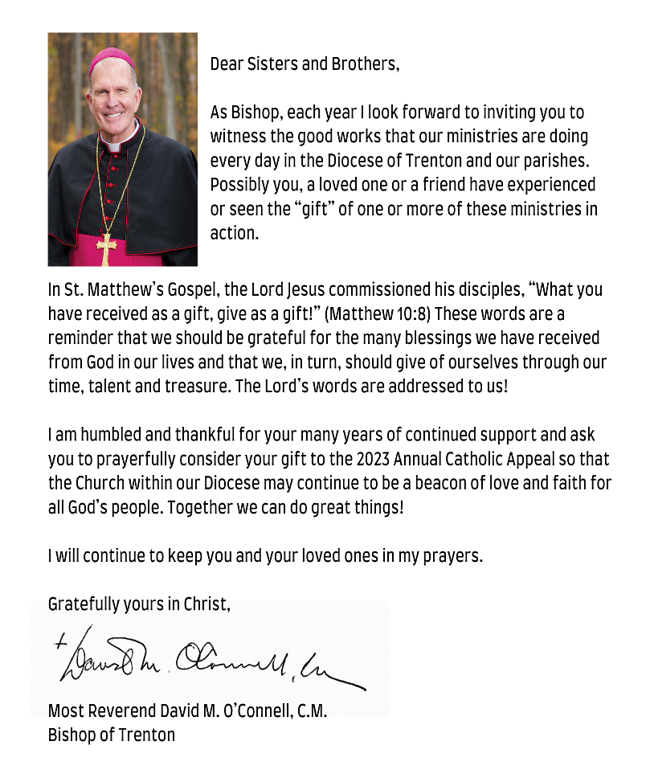
ANNUAL CATHOLIC APPEAL

FAST AND ABSTINENCE
Ash Wednesday and Good Friday are days of fast and abstinence. All Fridays in Lent are days of abstinence (no meat).
The days of FAST (only one full meal) and ABSTINENCE (no meat) are Ash Wednesday and Good Friday. No dispensations are granted on these solemn days except for reason of sickness or those provided in canon law below. All other Fridays of Lent are days of ABSTINENCE (no meat).
Those between the ages of 18 and 59 are obliged to FAST (only one full meal) as above. From the age of 14, people are also obliged to ABSTAIN (no meat: this obligation prohibits the eating of meat, but not eggs, milk products or condiments of any kind, even though made from animal fat).The obligation to observe the laws of fast and abstinence is a serious one for Catholics. Failure to observe one penitential day in itself is not considered a serious sin. It is the failure to observe any penitential days at all, or a substantial number of penitential days, that must be considered serious.
THIS YEAR’S GOAL $33,000.00

OFFICE OF THE BISHOP
February, 2023
Dear Sisters and Brothers in Christ,
During the days and weeks of penance that lie ahead --- from Ash Wednesday, February 22, 2023, until Holy Thursday morning, April 6, 2023 --- the Catholic Church throughout the world commemorates the penitential season of Lent ending with the Sacred Triduum of Holy Week. The model Jesus gave us for “these forty days” was his own experience in the desert and the temptations that followed him there where he encountered Satan face to face. And yet, Jesus, there in the desert --- alone, fasting and in intense prayer --- beat back the devil and triumphed over temptation, as strong and as unrelenting as it was throughout those forty days.
We enter the desert of Lent like Jesus, led by the Holy Spirit, to face our devils, our temptations head on. But we are not alone. The Lord Jesus Christ is with us. And so, too, is the Church, the entire community of faith observing Lent. Here is what the Catholic Church in the United States requires of us as baptized Catholics:
1. The days of FAST (only one full meal) and ABSTINENCE (no meat) are Ash Wednesday and Good Friday. No dispensations are granted on these solemn days except for reason of sickness or those provided in canon law below. ALL OTHER FRIDAYS OF LENT are days of ABSTINENCE.
The pastor of a parish has the faculty to give a dispensation to individual parishioners in his parish and the Diocesan Bishop alone has the authority to dispense groups of Catholics but only for a serious reason.
2. Those who are automatically dispensed from fast and abstinence regulations outside the age limits noted below include: the physically or mentally ill, especially individuals suffering from chronic illnesses such as diabetes. Also included in the dispensation are women who are pregnant or nursing. In all cases, common sense should prevail, and ill persons should not further jeopardize their health by fasting.
Those between the ages of 18 and 59 are obliged to FAST (only one full meal) as above. From the age of 14, people are also obliged to ABSTAIN (no meat): this obligation prohibits the eating of meat, but not eggs, milk products or condiments of any kind, even though made from animal fat).
The obligation to observe the laws of fast and abstinence is a serious one for Catholics. Failure to observe one penitential day in itself is not considered a serious sin. It is the intentional failure to observe any penitential days at all, or a substantial number of penitential days, that must be considered a serious matter.
The obligation, the privilege really, of receiving the Eucharist at least once a year --- often called “Easter duty” --- for those in the state of grace should still be fulfilled during the period from the First Sunday of Lent, February 25-26, 2023, to Trinity Sunday, June 3-4, 2023. However, the Church’s law does permit this precept to be fulfilled at another time during the year when there is a just cause.
I want to encourage all Catholics, especially those who are conscious of serious sin, to go to confession and to make use of the sacrifices and traditions that have always been part of our Lenten practices in the Church.
We do, indeed, fast and pray with the Lord Jesus and with our fellow Catholics. May this Lent be a time of penance leading to grace and joy for us all at Easter.
Sincerely yours in Christ,
Most Reverend David M. O’Connell, C.M.
Bishop of Trenton

